**SQL statements:**

CREATE TABLE STATES2_table

(

stateAbbr VARCHAR(2) PRIMARY KEY ,

stateName VARCHAR(20) NOT NULL ,

);

CREATE TABLE CITY1_table

(

cityID CHAR(8) PRIMARY KEY ,

cityName VARCHAR(20) NOT NULL ,

stateAbbr VARCHAR(2) FOREIGN KEY(stateAbbr) REFERENCES STATES2_table(stateAbbr) NOT NULL,

);

CREATE TABLE AIRPORT1_table

(

airportID CHAR(3) PRIMARY KEY ,

airportName VARCHAR(45) UNIQUE NOT NULL ,

cityID CHAR(8) FOREIGN KEY(cityID) REFERENCES CITY1_table(cityID) NOT NULL,

);

SELECT * FROM AIRPORT_table

CREATE TABLE FLIGHTS_ROUTE1_table

(

flightNumber VARCHAR(6) PRIMARY KEY ,

departAirport CHAR(3) FOREIGN KEY(departAirport)REFERENCES AIRPORT1_table(airportID),

arriveAirport CHAR(3) FOREIGN KEY(arriveAirport)REFERENCES AIRPORT1_table(airportID),

scheduledDepartTime TIME NOT NULL,

scheduledArrivalTime TIME NOT NULL,

);

CREATE TABLE FLIGHTSTATUS2_table

(

statusID CHAR(1) PRIMARY KEY NOT NULL,

CONSTRAINT chk3_statusID CHECK (statusID='O'OR statusID='C' OR statusID='D'),

description VARCHAR(20) NOT NULL,

);

CREATE TABLE AIRCRAFTSPECS1_table

(

aircraftTypeID CHAR(8) PRIMARY KEY NOT NULL,

aircraftVersion VARCHAR(10) NOT NULL,

cabinNumOfSeats INT,

fuelCapacity INT NOT NULL,

);

CREATE TABLE AIRPLANE1_table

(

airplaneID CHAR(8) PRIMARY KEY NOT NULL,

aircraftTypeID CHAR(8) FOREIGN KEY(aircraftTypeID) REFERENCES AIRCRAFTSPECS1_table(aircraftTypeID) NOT NULL,

purchaseDate DATETIME Default '01/02/2014' NOT NULL,

);

CREATE TABLE FLIGHTSCHEDULE112_table

(

flightNumber VARCHAR(6) NOT NULL,

CONSTRAINT FK1_FlightNumber foreign key (flightNumber)REFERENCES FLIGHTS_ROUTE1_table(flightNumber),

flightDate DATE,

CONSTRAINT PK1_xyz PRIMARY KEY (flightDate,flightNumber),

statusID CHAR(1) FOREIGN KEY(statusID) REFERENCES FLIGHTSTATUS2_table(statusID) NOT NULL,

CONSTRAINT ck1_statusID CHECK (statusID='O'OR statusID='C' OR statusID='D'),

airplaneID CHAR(8) FOREIGN KEY(airplaneID)REFERENCES AIRPLANE1_table(airplaneID) NOT NULL,

delayDepartTime TIME ,

delayArrivalTime TIME,

);

INSERT INTO STATES2_table

VALUES

('CA','California'),

('DC','Washington.D.C.'),

('FL','Florida'),

('IL','Illinois'),

('MA','Massachusetts'),

('NY','New York'),

('TX','Texas')

SELECT * FROM STATES2_table

INSERT INTO CITY1_table

VALUES

('C001','Los Angeles','CA'),

('C002','San Francisco','CA'),

('C003','Washington.D.C.','DC'),

('C004','Miami','FL'),

('C005','Orlando','FL'),

('C006','Chicago','IL'),

('C007','Boston','MA'),

('C008','New York','NY'),

('C009','Syracuse','NY')

SELECT * FROM CITY1_table

INSERT INTO AIRPORT1_table

VALUES

('BOS','Darji','C007'),

('DCA','Ronald Reagan National Airport','C003'),

('IAD','Washington Dulles International Airport','C003'),

('JFK','John F. Kennedy International Airport','C008'),

('LAX','Los Angeles International AIrport','C001'),

('LGA','LaGuardia Airport','C008'),

('MCO','Orlando International Airport','C005'),

('MDW','Chicago Midway International Airport','C006'),

('MIA','Miami International Airport','C004'),

('ORD','Chicago O Hare International Airport','C006'),

('SFO','San Francisco International Airport','C002'),

('SYR','Syracuse Hancook International Airport','C009')

SELECT * FROM AIRPORT1_table

INSERT INTO FLIGHTS_ROUTE1_table

VALUES

(3310,'SYR','JFK','08:00:00.0000000','09:02:00.0000000'),

(3312,'JFK','SYR','12:20:00.0000000','13:30:00.0000000'),

(3426,'LAX','ORD','11:15:00.0000000','15:05:00.0000000'),

(5063,'BOS','MCO','14:30:00.0000000','18:45:00.0000000')

SELECT * FROM FLIGHTS_ROUTE1_table

INSERT INTO FLIGHTSTATUS2_table

VALUES

('C','Cancelled'),

('D','Delayed'),

('O','On Time')

SELECT * FROM FLIGHTSTATUS2_table

INSERT INTO AIRCRAFTSPECS1_table

VALUES

('AIR1','A321-200',220,7930),

('AIR2','737-600ER',132,6875),

('BOE1','747-400ER',416,63705),

('BOE2','767-300ER',350,23980),

('BOE3','737-600ER',132,6875)

SELECT * FROM AIRCRAFTSPECS1_table

INSERT INTO AIRPLANE1_table

VALUES

('AP098640','AIR2','2013-03-01'),

('AP239471','AIR1','1900-01-01'),

('AP309814','BOE2','2012-05-22'),

('AP629342','BOE1','1900-01-01'),

('AP872139','BOE3','1900-01-01'),

('AP998911','BOE2','1900-01-01')

SELECT * FROM AIRPLANE1_table

INSERT INTO FLIGHTSCHEDULE12_table

VALUES

(3310,'2014-02-10','O','AP629342','',''),

(3310,'2014-02-11','O','AP629342','',''),

(3312,'2014-02-10','O','AP872139','',''),

(3426,'2014-02-12','O','AP239471','',''),

(5063,'2014-02-13','D','AP309814','15:40:00.0000000','20:05:00.0000000')

SELECT * FROM FLIGHTSCHEDULE12_table

**SQL STATEMENTS AND OUTPUS SCREENSHOTS:**

State Table:

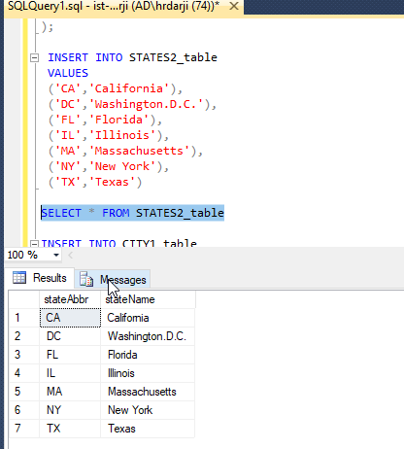

CITY TABLE:

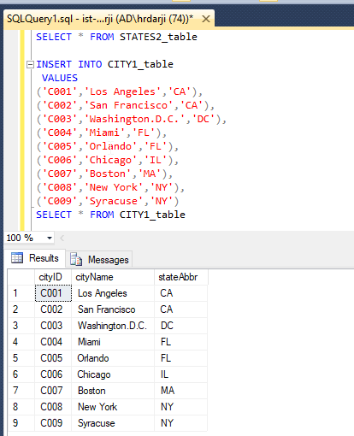

AIRPORT TABLE:

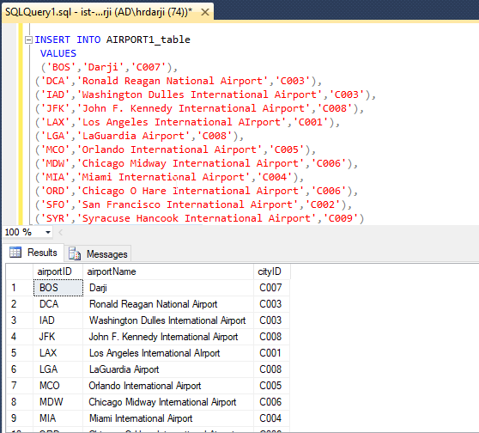

FLIGHT ROUTE TABLE**:**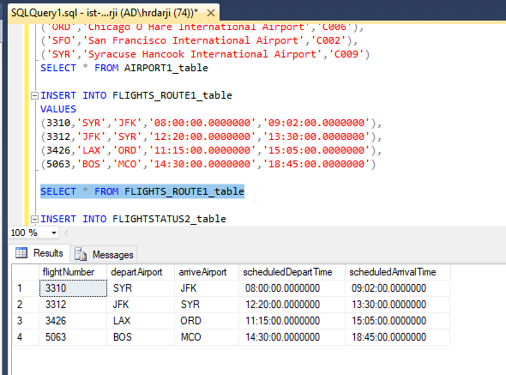

FLIGHT STATUS TABLE: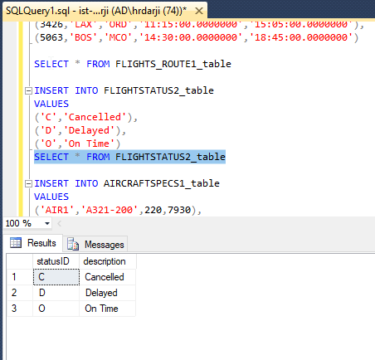AIRCRAFT SPECS TABLE: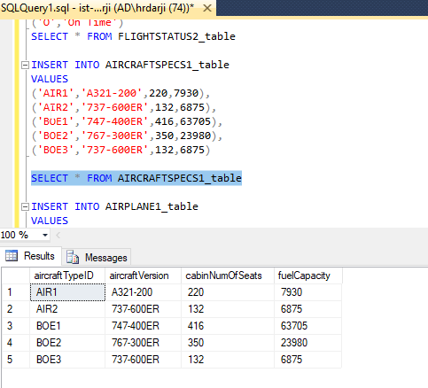

AIRPLANE TABLE:

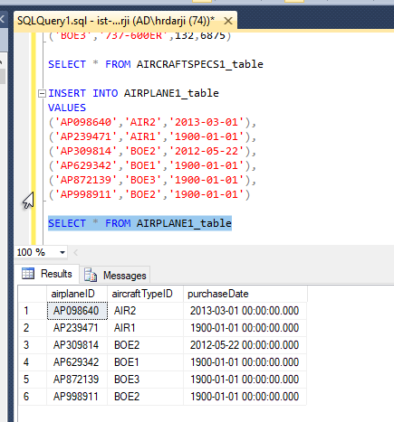

FLIGHT SCHEDULE TABLE: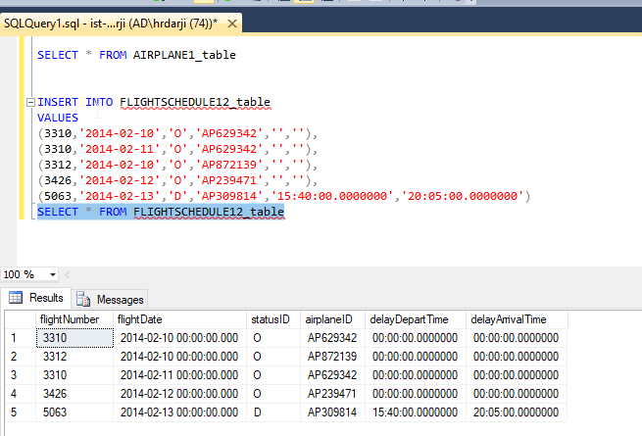

**QUERIES:**

1.Find all aircrafts whose fuel capacity is less than 63705. Show aircraft id, cabin number of seats and fuel capacity.

-🡪 SELECT aircraftTypeID, cabinNumOfSeats,fuelCapacity FROM AIRCRAFTSPECS1_table

WHERE fuelCapacity < 63705;

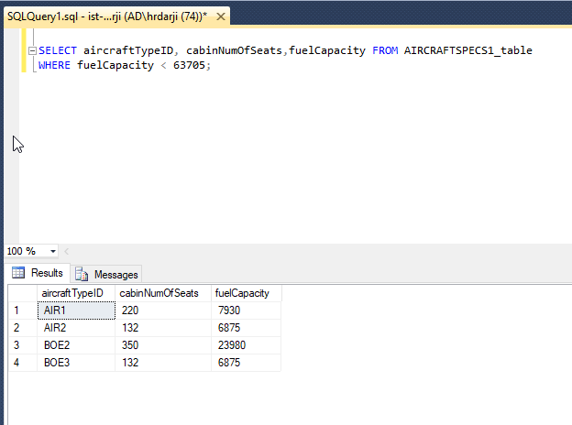

2.Find all airplanes which were on time or delayed. Show only airplane ID, flight date and statusID.

🡪 SELECT airplaneID, flightDate, statusID from FLIGHTSCHEDULE12_table

WHERE statusID='O' or statusID='D';

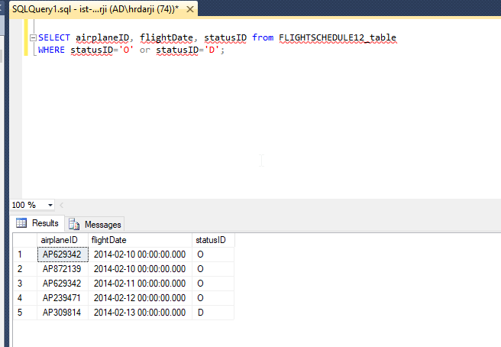

3.Find all the airplanes that have been purchased before the year 2013-02-10. Show airplane id and the purchase Date.

* SELECT airplaneID, purchaseDate from AIRPLANE1_table

WHERE purchaseDate<'2013-02-10';

